ProDoula is proud to provide you with the attached badges to display your certification on your website. There are many ways to add these images to your site, with a link back to ProDoula. Below is an example of how to add the images to a WordPress site, many other website builders have similar methods to adding images with links so these basic steps should get you started.

Open the page that you wish to add the certification image to in your website builder.
Select the location for the image and add it as a media file.

Select the certification image and insert into page.

Click on the certification image and select the insert hyperlink box from your website builder’s menu.

Enter www.prodoula.com as the destination of the hyperlink on the image and save.
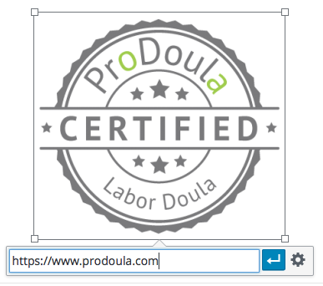

Update, publish or save the page and check to make sure that it works. Repeat for each certification image.

You’re all set!

